Paper 2:

Tianrui Liu and Tania Stathaki, “**Enhanced Pedestrian Detection using Deep**

**Learning based Semantic Image Segmentation”,** 22nd International Conference on Digital Signal Processing, 2017.

Architecture:

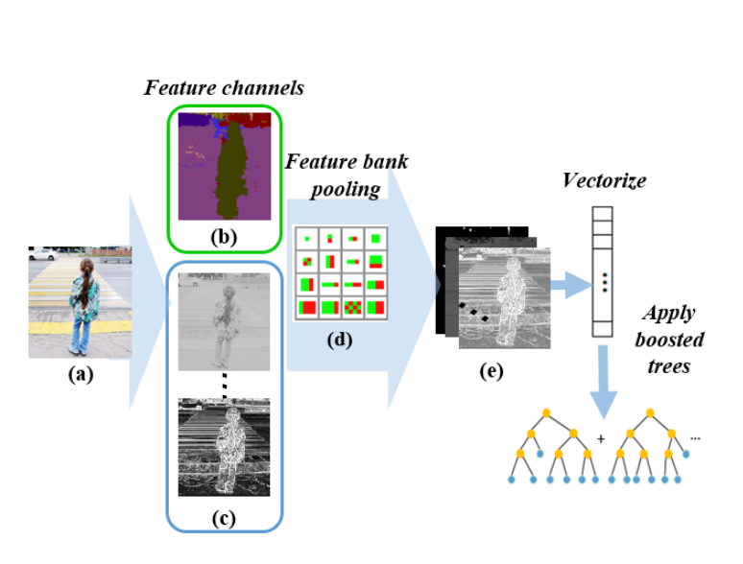

Methodology:

1. Semantic Image Labeling for Pedestrian Detection: A deep learning based semantic segmentation

method is used to perform semantic image labeling for the proposed detector. Semantic image labeling aims to assign every pixel of an image with an object class label, challengingly combining image segmentation and object recognition in a single process.The SegNet architecture is trained using Caffe-SegNet on a large database combining a set of urban traffic images as in . 11 common semantic classes are usedfor training: building, tree, sky, car, sidewalk, column pole,sign-symbol, road, fence, pedestrian and bicyclist; while pixels of other classes are labeled in black and will be ignored during training.

2.Filtered Channel Features based Pedestrian Detector using Semantic Image Segmentation:

Here the integration of semantic image segmentation results with baseline detectors which use filtered channel features. In Aggregated channel features an input image is transformed into a set of feature channels, 10 HOG+LUV channels which contain 6 gradient orientations, 1 gradient

magnitude, and 3 color channels

3.Integrating Semantic Feature for Pedestrian Detection: Given an image, 10 HOG+LUV feature channels are computed efficiently using integral images. Semantic features in are obtained from the deep learning based semantic labeling method.

4. Boosted Forest for Integrated Feature Channels:Boosted Forest is an ensemble learning method which can achieve fast and accurate classification by training accumulated hard negatives samples in cascade. Owing to high accuracy and low computation cost, decision forests have been widely

used in computer vision tasks such as image classification, object recognition, and super-resolution.

Limitations:

Computationally expensive in terms of graphic performance.There is still a lot of work to be done since a robust system should work effectively under a variety of environmental conditions.